1/1/2016

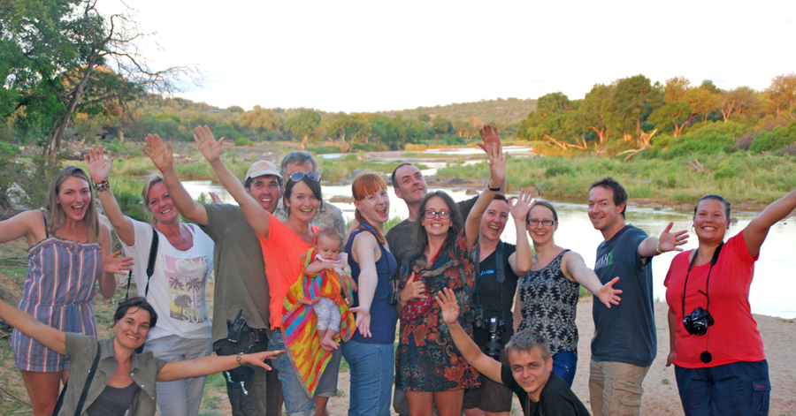
WHEN YOU GET HERE

14

WELCOME TO C.A.R.E.

ACCOMMODATION
Our brand-new “Volunteer Village” is complete and our volunteers love the new space! The accommodation contains 6 rooms, each housing between 2 and 4 people each. There are new toilet and shower facilities, where volunteers get to wash while gazing up at the beautiful South African sky. There is a small volunteer kitchen, as well a communal games room, with ping-pong, darts, TV/DVDs. The bedrooms are situated around a beautiful communal garden space and braai (BBQ) area. The Volunteer Village is located within “The Rebuild” area, surrounded by a secure electric fence.
You will hand in your forms to the “office”, settle your transfer/entrance fees and be shown to your room. Usually you will proceed to get a tour of C.A.R.E., be sure to drink plenty of water on your first day! Let yourself get settled in, get plenty of rest, get to know your fellow volunteers and be prepared for the experience of a lifetime!

48 HOUR NO CONTACT POLICY
For the first 48 hours at C.A.R.E. we have a “No Contact Policy” whereby we ask you not to touch any baboons for the first 48 hours. This is to minimise the risk of any coughs or colds coming into the centre to protect the baboons. Don’t worry this time flies by and is the perfect opportunity for you to get orientated, learn the bottle and food preparation shifts, learn a little about the baboon behaviours to get some tips on how to act when you meet the orphans and work with the adult baboons. Meeting the baboons will be an experience you will never forget and we wish you luck preparing for your trip!
Am I really helping make a difference or is this just another “nice experience”?

14

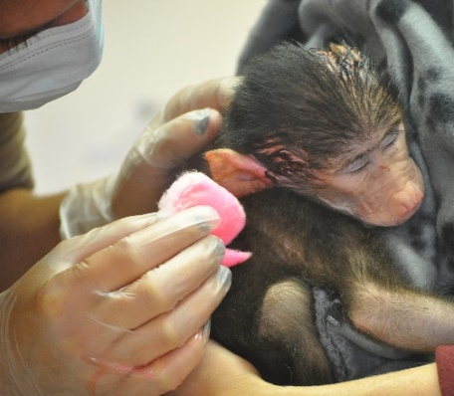
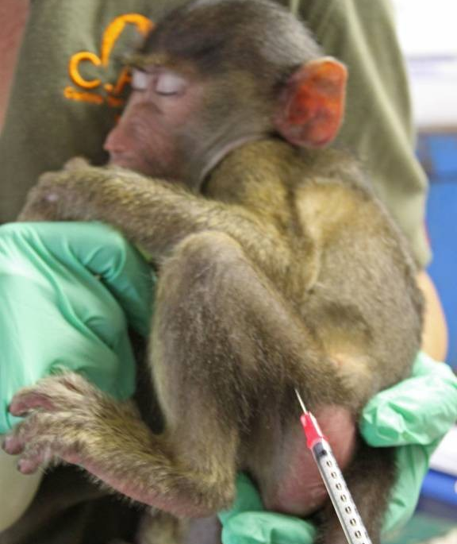
Rest assured; through simply paying your donation you have already made a difference. The volunteer program funds the majority of the day-to-day expenses. Housing, feeding and caring for almost 440 baboons is an expensive undertaking and your donation helps to cover these immense costs. In addition to the donation, as a volunteer at C.A.R.E. you really are a key member of the work-force! We can’t afford the salaries to cover all the staff roles needed at the centre and rely on people like you to act as though you are an employed member of the team. The “Volunteer Experience” isn’t a holiday. Whilst we do urge all volunteers to take a day off each week (for example to the lodge next door for a relaxing day at the pool-side) and try to ensure you have a fabulous time, you will for the rest of the time be helping out with the day-to-day husbandry. You will get hot, tired, peed and pooped on and can be confident that C.A.R.E. isn’t a place where we make things up for volunteers to do; you are needed! You are key to helping us make a difference! The baboons especially need you for their physical and psychological healing and development.
Physical healing…..

C.A.R.E. is run primarily by volunteers. We have a paid staff of 11+/- (African’s) and the rest (including the management) are for the most part volunteers. The jobs you will be doing is helping the over-all day-to-day tasks; you will be making a real difference to the animals’ lives and support the progression and success of the centre itself.

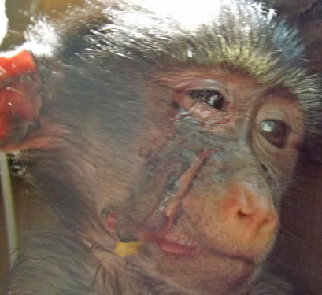
There will be incredible, life changing moments during your stay with feelings of elation and achievement, and there will also be times that aren’t so great; picking up poop, scrubbing poles and sorting through fruit and veg! The “experience” is not all about cuddling baby baboons, always remember; the baboon orphans are at the centre because their families were killed and one day they grow up into adults, who still need lots of hard work to care for. Baboons are really only babies for 6-8 months, from there on those same babies have to face life in a troop and we love for the volunteers to help in all stages of the rehabilitation/husbandry, which at times can be hard work.
Maintaining health….

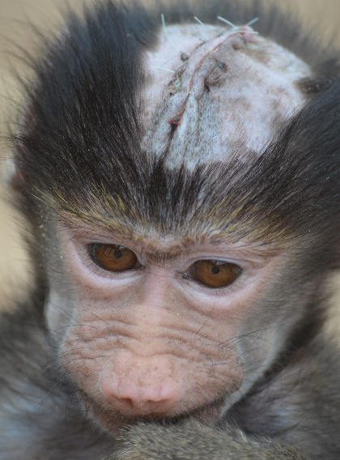
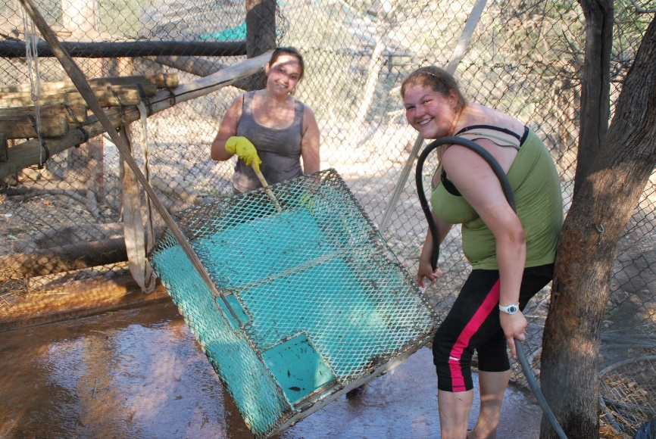
Psychological healing….

Husbandry; keeping enclosures clean and maintained….

Giving the baboons a life and a future which human cruelty took away….

YOUR ROLE AS A VOLUNTEER

15

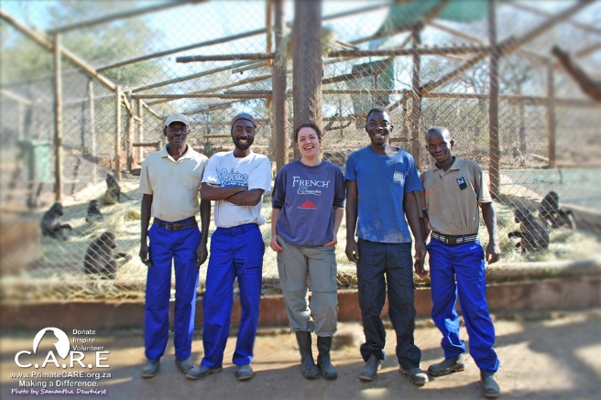
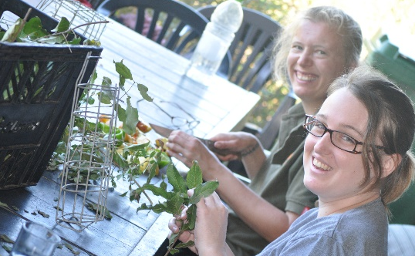
You are at C.A.R.E. as a helping hand and are expected to act as a professional in training. It is important that you listen, learn, use your initiative and act like a professional. At the end of a hard day you can put your feet up, let your hair down and ask for a day off at the lodge next door or go on another excursion. However, whilst working and walking around the Centre we expect you to be a capable member of the C.A.R.E. team and help us to achieve great things for the baboons!
Key part of the animal care team….

It is important to remember that the line of ‘authority’ does not stop at our Managing Director, Stephen. He too has to answer to the authorities and report to them in order to obtain permits to release and operate. We expect you as a volunteer to help Stephen achieve for the baboons and get them out of the cages back into the wild where they belong!
If everyone does a little, we do achieve a lot for these amazing animals! So we ask volunteers to please ensure the area of running C.A.R.E. which you have been assigned to gets done well. We want you to be proud to be part of the team and proud of the work you have done before you exit the area. It is important that you realise how vital it is that the ‘little things’ get done properly and we work with a “bottom up” attitude rather than “top down”.
Making Enrichment Toys….

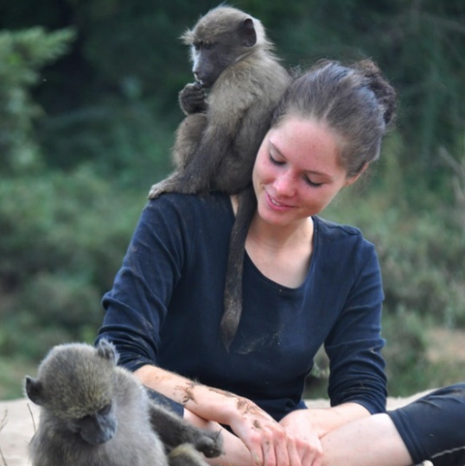
SOME OF THE THINGS YOU WILL BE HELPING WITH….
Day to day activities vary and are dependable on how many infant orphans are in need of help (if any) and how many volunteers there are present at the centre. When we have baby orphans a lot of the voluntary role is based around their care;
- Supervising any orphan babies in the nursery; ensuring they are emotionally secure, eating, resting, playing, socialising
- Preparing and giving bottles/food
- Cleaning their play-space
- Cleaning the baboon kitchen/work space, food store
- Bonding babies to a baboon surrogate mother and supervising interactions
Supervising orphans and integrations….

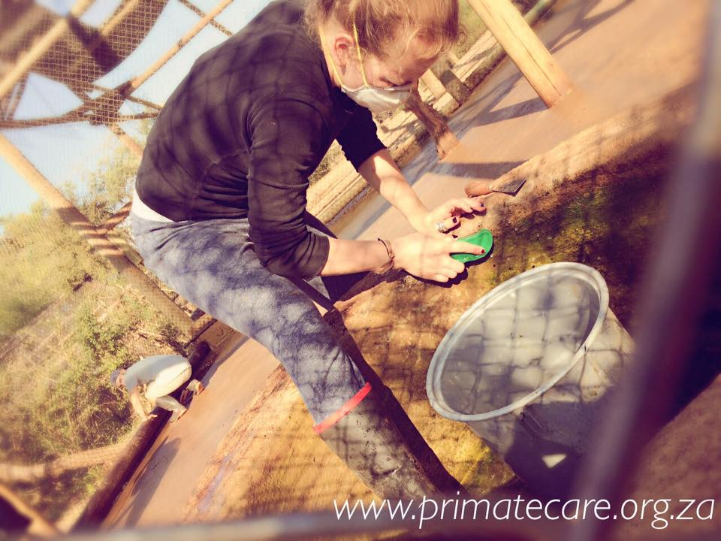
The majority of the population at C.A.R.E. are in Phase II rehabilitation; the hands-off phase. These animals are being prepared for a life in the wild, so they are maturing, bonding and settling ranks. Whilst in the hands-off phase we still need your help to;
Cleaning enclosures….

- Make enrichment & food
- Collect behavioural data
- Clean and maintain enclosures
- Build climbing structures
- Collect grass, natural foliage, seed pods and elephant dung
- Go on trips to the local farms to help load vehicles of food/unload
- Sort through fruit/veg/bread (good from bad)
- Clean and organise areas of the centre as needed
- Complete alien plant removal and other reserve management activities
- Map vegetation data as needed
- Help with the domestic rescued animals (chickens, dogs, cats, guinea-pigs)
- Help with any other rescued animals undergoing rehabilitation
15

YOUR ROLE AS A VOLUNTEER Continued…..

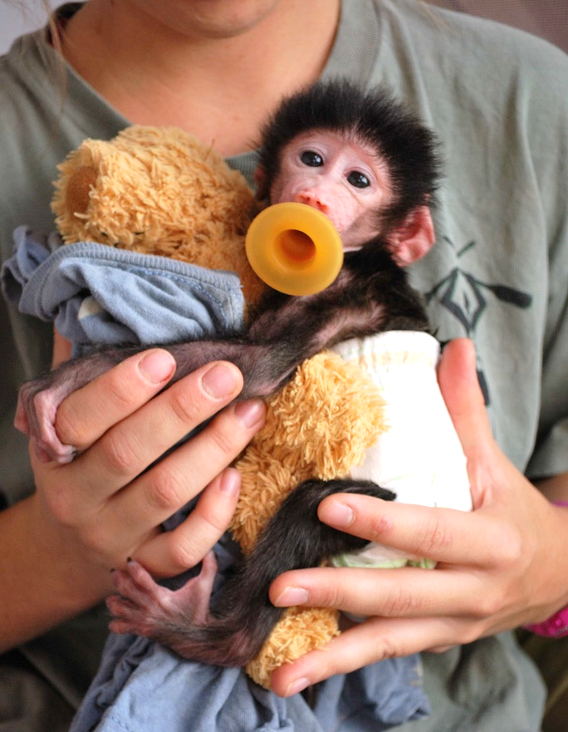
How do I help the baboons through hand-rearing?
IF WE HAVE ORPHANS AT THE TIME OF YOUR STAY: Baboon babies are born helpless and they need hands-on nurturing in order to ensure they are developing. In addition to physical development, the babies need humans to support them emotionally. Baboon babies bond strongly to their mothers and if this bond is broken through the mother being killed, the baby becomes insecure and traumatised. At C.A.R.E. we provide the babies with a human surrogate when they are infants to ensure they get a stable upbringing. The surrogate, like their baboon mothers, take care of them 24/7. The babies get exposure with other baboons from day 1 at C.A.R.E.; this is very important! They learn many important behaviours from spending time with other baboons. We have found that if the baby bonds to the surrogate they fear unknown humans more readily, which is important for when they face release. If the baboons are handed around to anyone and everyone, they lose all fear of people, which isn’t ideal for rehabilitation and release. Human surrogates are normally long-term volunteers (often staff and/or return volunteers at the centre for 4+months), but the short-term volunteers also help through acting as an Aunty/Uncle- just as other baboons would in the troop.
Baboon infants are helpless and need humans to help them with feeding and emotional security.

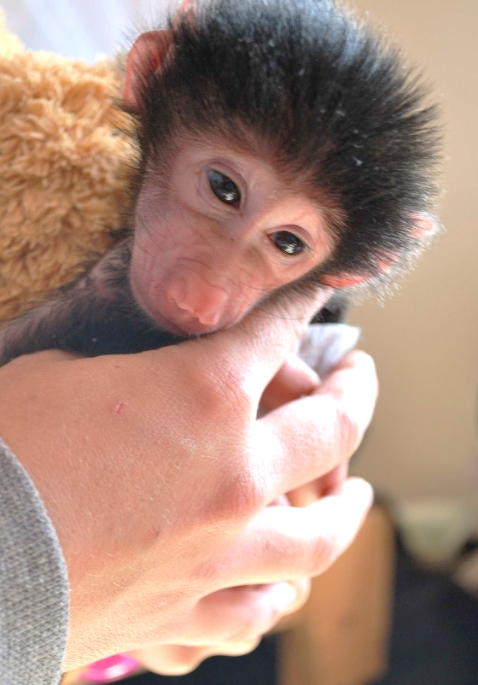
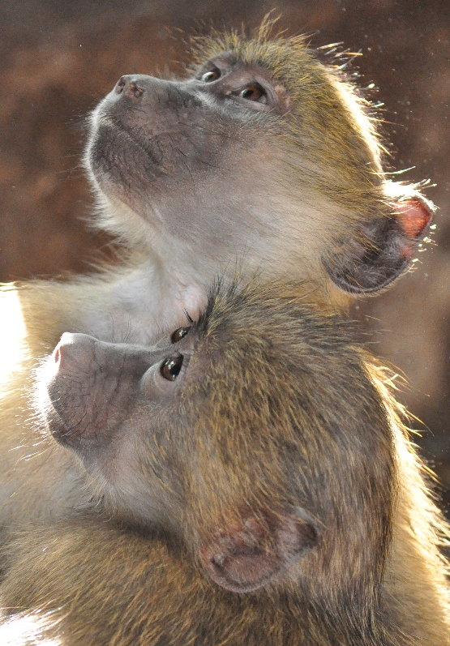
The infants are supervised by medium term volunteers and short term volunteers who act as Aunts/Uncles during the day. Volunteers supervise them in the nursery during the day and when the babies are being bonded to a baboon surrogate. This is at an age where in the wild they would also be left by their mothers with baboons they know well and can take care of them for short bouts of time. This is also when the babies begin to bond to the other baboons and depend less on humans for help with bottle feeding, etc.
When the baboon babies grow up they begin to rely on their “baboon friends” more and are weaned from their human surrogate. Bonding to other baboons is essential for the baby, as it must belong to a new baboon family in order to face a life in the wild. Human volunteers help to facilitate these special bonds.

How do I help “bond orphan babies to “baboon surrogate mothers”?
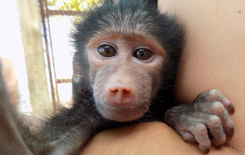
There may or may not be baboon orphans at this stage of rehabilitation during your stay. When the infant orphans can climb more effectively, move about confidently and recognise a bottle as nourishment/will come for a bottle, staff and volunteers begin to introduce them to a baboon female who will act as their surrogate mother. The female would be chosen from one of our troops who are awaiting release. Initially, they will only spend a few hours a day being introduced, and the rest of their time playing with the other orphans in the nursery. This helps them to become confident which is needed when meeting an adult baboon female. The more confident the baby, the more time spent bonding with the adult female; the confidence comes from the early security they had in their surrogate and exposure to other baboons.
Previously, C.A.R.E. formed troops made completely of orphan babies in a peer-rearing setting with some human hand-rearing. These babies came in over the course of about year and would be strongly bonded – they are now at the centre to grow and mature so that they can be released. A baboon begins to mature sexually from about 4.5 years of age, emotional maturity comes a few years after that.
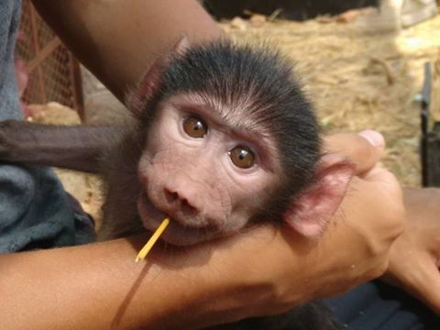
Presently, we have several formed troops which are mature and ready for release. We can take females from within these troops to bond with an incoming orphan. This means the orphan will spend much less time in captivity and a fraction of time having hands-on contact with humans. Once bonded, the female and her new adopted baby are returned to the troop and so far – the babies have always been accepted well. This refined methodology is much better for the baboons and we aim to continue to refine the rehabilitation methods. The bonding process can take between 2 – 6 weeks.
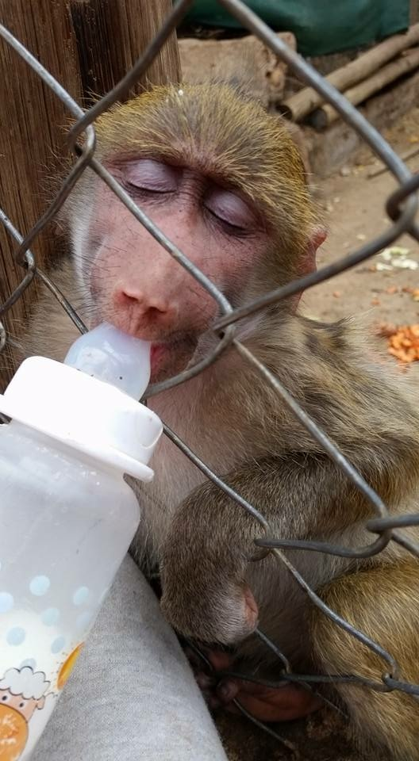
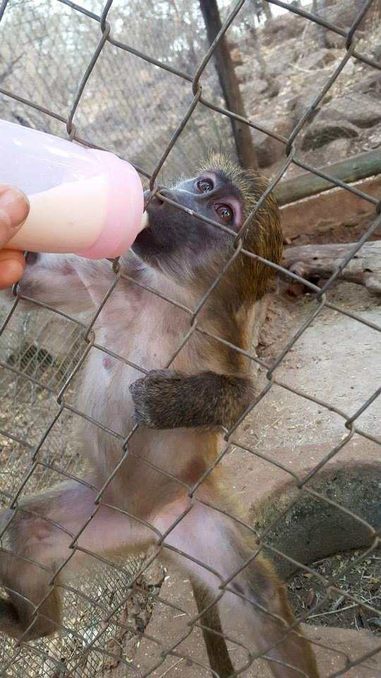
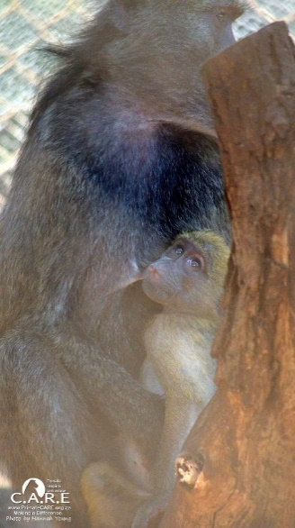
The volunteers help with this bonding and integration process. Firstly, the baby is settled with the human care-giver and due to the relationship they have built, they are confident in their presence. The human care-giver can then sit with the baby in a custom built “introduction enclosure”. The introduction enclosure has two sides with a sliding door in between. The sliding door is opened slightly so that the baboon orphan can fit through. On one side the volunteer care-giver will sit and on the other side the potential baboon surrogate mother will sit. Initially the orphan can be very scared of the adult female and the human care-giver helps to reassure. Eventually, the baby builds up enough confidence to go through the sliding door and quickly begins to choose to spend more time with the baboon female. Even from a young age, baboons want to be with baboons!
The orphans still need milk when they are weaned from the nursery to be with the baboon surrogate. Volunteers give milk through the fence. They receive milk formula as they would still be drinking from their wild mothers. Sadly their wild mothers were killed, which is why they are at C.A.R.E. needing rehabilitation.
Photo by volunteer Beccy Cleeves.
Gradually, slowly, at the orphans pace, a relationship is formed between the baboon infant and adult female; baboons clearly want to be with their own kind, and with time, the baby no longer spends much, if anytime with the human care-giver. This is when the human care-giver will step away. Sometimes, the baby will get scared and make “contact-calls” to the human care-giver but, usually, quite quickly the adult female will reassure the baby. Eventually, the adult female baboon and baby spend 24/7 together; grooming, playing, eating and sleeping. The volunteers still feed milk to the babies through the fence, but the contact from thereon becomes minimal. Eventually, the staff make the decision to move the female and her new adopted baby back to her troop.
The new bonding enclosures allow for the smooth and safe bonding of an adult baboon female from a rehabilitated troop to bond with an incoming orphan baby. We’ve observed babies like Maple (above) even suckling for comfort on the teats of their surrogate mother.

From thereon, volunteers make behavioural observations and continue to feed milk through the fence for a few months until the baby no longer needs milk formula. Success! The baby has been adopted into a formed, bonded, mature troop and years spent in captivity should be minimal! Thanks to the volunteers through helping with every step of the process.
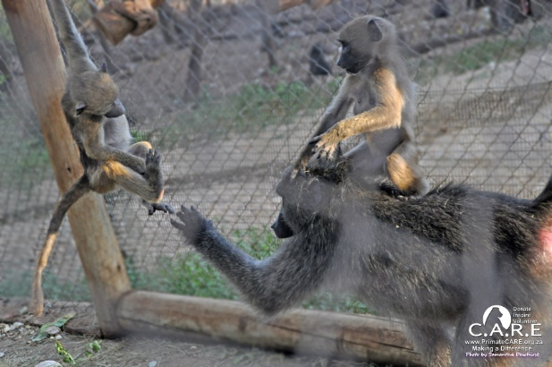
Both surrogate baboon mother (once an orphan herself) and baby orphan baboons benefit from the bonds they share. It enriches both their lives.

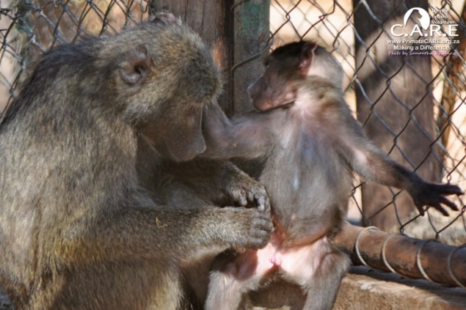
Bonding orphan babies to baboon females in captive troops awaiting release benefits the orphan as it means less time in captivity and with humans, it is also more natural. Additionally, it has a positive impact on the surrogate baboon female and her troop; it encourages positive behaviours; playing, grooming, nurturing. Females which hadn’t been observed playing since they were juveniles have been observed giggling, bouncing and play-facing again.

Photo by volunteer Chelsea Musick.

How many baboons are at C.A.R.E. that cannot be released and how will I help them?
15

YOUR ROLE AS A VOLUNTEER CONTINUED……

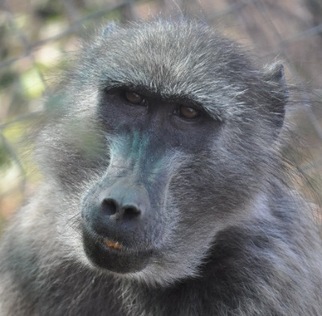
Presently (January 2017) there are four baboons at C.A.R.E. which are not part of a releasable troop and classed as “unreleasable”. They are unreleasable mostly due to age. An exception is Stevie Wonder, who wouldn’t survive in the wild as he is blind / brain-damaged. The four unreleasable baboons which you will work with are; Hope, Ayana, Stevie Wonder and Patats. The rest of the baboons at the centre are at various stages of rehabilitation or within a releasable troop.
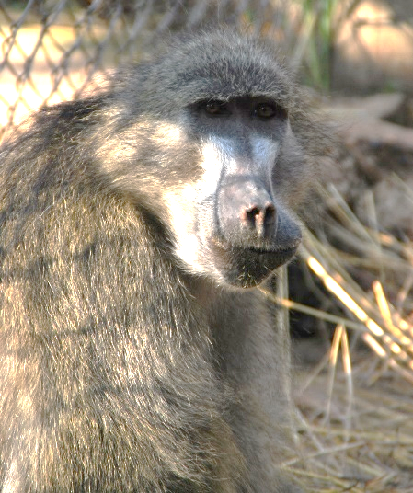
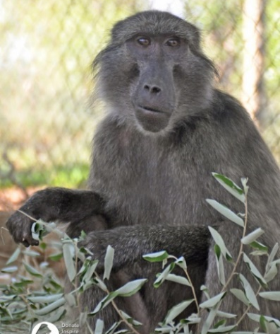
Hope and Ayana were rescued from the biomedical research industry. Whilst a number of other females were rescued at the same time and found a place in a releasable troop, these two ladies aren’t physically or psychological suitable for release. They have very bad teeth which would mean they would slowly starve in the wild, additionally, they are very old and the psychological damage caused through living alone previously has meant they find life in a troop hard. Often they shut down when faced with any social stress and lose weight/condition quickly as a result. Ayana in particular has a soft personality and becomes stressed easily and struggles to deal with troop politics. Hope has a very strong personality. This, coupled with her past (being housed singly in a biomedical research setting), means that she often reacts defensively in social situations, resulting in aggressive combat. Hope and Ayana have found comfort in one another’s company and enjoy grooming and resting together. Volunteers can enter the enclosure with these two ladies to clean them out and give them enrichment.
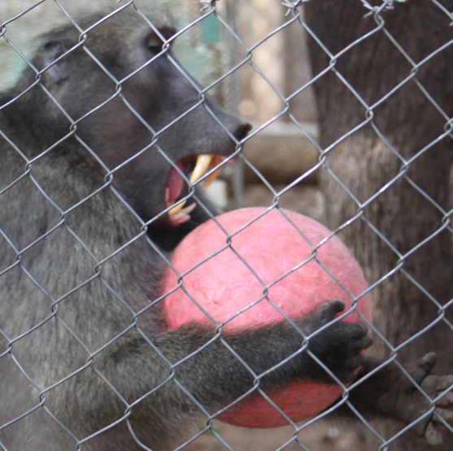
Patats is a very elderly female who was once welded into a steel drum so that her faeces could be harvested by a “Songoma” (witch doctor) for “muti” (a form of “traditional/cultural” medicine. There is no evidence that baboon faeces has medicinal qualities for humans). Patats has very old (and very few) teeth, meaning she couldn’t survive in the wild. She finds it hard to interact with other baboons, being elderly she gets bullied and the stress causes her to lose weight as a result. We aim to give Patats an enriching life in captivity. Volunteers enjoy grooming with this sweet female, making her enrichment toys and other special treats. Patats is VERY popular with everyone at C.A.R.E. due to her super-sweet nature and eager-to-please personality.
Stevie Wonder arrived at C.A.R.E. already as a fully-grown, stunning adult male. When he was younger Stevie was beaten almost to death, which resulted in permanent brain damage, and he is also partially sighted. Due to his condition he cannot be released into the wild and also cannot be housed in a troop setting as he doesn’t know how to respond appropriately to various social gestures. Stevie really enjoys the various enrichments which volunteers make for him and the volunteers help keep his enclosure clean and his mind stimulated. Volunteers do not enter Stevie Wonders enclosure whilst he is inside; his enclosure is specially designed to allow him to be enclosed in one half while volunteers enter the other safely and vice-versa. Stevie Wonder presently lives besides a releasable troop and he enjoys grooming the troop next door and engaging in other normal social situations.
These four very special baboons enjoy life living in enclosures that are within their natural habitat and surrounded by both wild and captive baboons, which they enjoy controlled/safe interactions with. They love grooming baboons through the fence and we often trial various social settings with them to try and forge friendships between them enabling them to live in at minimum a pair.
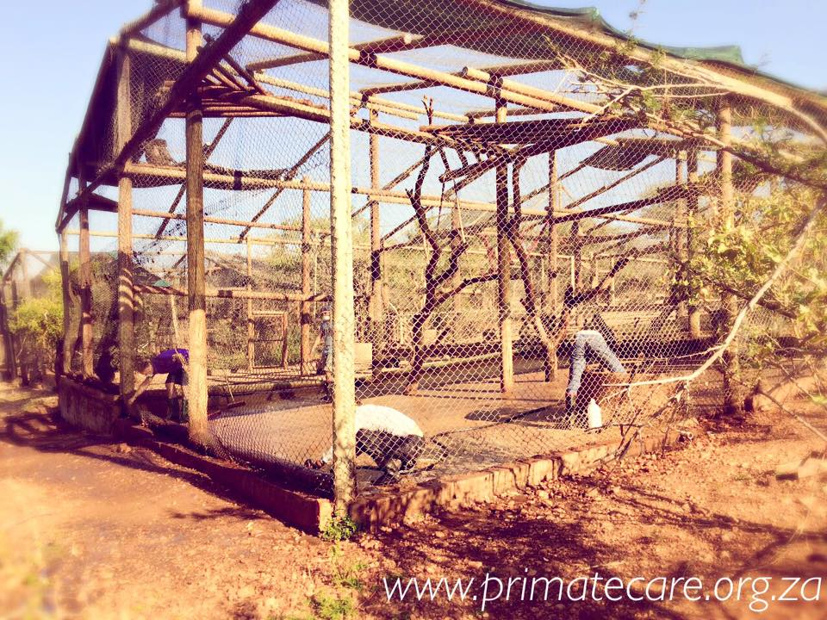
YOUR ROLE AS A VOLUNTEER CONTINUED……

YOUR ROLE AS A VOLUNTEER CONTINUED……

How many baboons are at C.A.R.E. that cannot be released and how will I help them?
Volunteers assist with the husbandry aspects of 4 unreleaseable baboons by:
- Collecting and giving natural vegetation; seed pods, branches, leaves, bark, fresh and dry grass, this helps with their digestion, keeps them busy and also enables them to live a more natural life.
- Making and giving enrichment; making mostly natural “toys” and interesting items for the baboons such as pasting vegetation with special food pastes and seeds, making foraging boxes, making ‘taste’ logs and rocks and other interesting items to keep their minds stimulated in a natural way.
- Making them food; these baboons often have very bad teeth and have to be specially catered for.
- Cleaning them out; enclosure cleaning is a major part of the husbandry and so important to keep the baboons happy and healthy. The work can be hot and tough, but seeing the baboons enjoy your hard work is very rewarding.

How do I help the older baboons that are being prepared for or waiting for release?
- The orphan baby baboons grow quickly and in most situations by 5+/- months old are bonded to a baboon surrogate mother within a releasable troop. The troops awaiting release need a lot of care and whilst the locally employed African labourers which live on-site are responsible for most of their husbandry volunteers also assist in the following ways;
- Collecting natural vegetation; seed pods, branches, leaves, bark, fresh and dry grass, this helps with their digestion, keeps them busy and also enables them to live a more natural life. It is important to give the baboons natural foods as this is what they will be eating once released too. Most volunteers enjoy learning about the natural vegetation and what the baboons will eat in the wild.
- Making and giving enrichment; making mostly natural “toys” and interesting natural items for the baboons such as pasting vegetation with special food pastes and seeds, making foraging items, making ‘taste’ logs and rocks and other interesting things to keep their minds stimulated in a natural way and to promote foraging behaviours.
- Making them food; washing, chopping and prepping food for the releasable troops.
- Cleaning them out; enclosure cleaning is a major part of the husbandry and so important to maintain happy and health animals.
We have some semi-wild enclosures which require minimal maintenance as they are large and like in the wild the natural organisms present in the environment break down any waste materials, however, most of the enclosures are smaller rehabilitation enclosures and require cleaning out regularly. We are in the process of updating all the enclosures to cement the bases and include sliding doors; for those enclosures which are already renovated volunteers can safely enter to clean. Volunteers help to remove the waste, hose and scrub the floors, water dams and poles and then add natural substrates and enrichments for the troop. It is very rewarding to see the baboons enjoying the clean and enriched space. We appreciate that some volunteers may be physically unable to participate in these activities and tailor the daily schedules to meet each individual’s personal needs, but most volunteers enjoy this physical activity.
- Data collection; volunteers are trained to observe and collect data on the baboons. The volunteers often enjoy learning about the various behaviours, vocalisations and gestures which the baboons perform. Data is collected mostly on the baboon orphans which have been bonded to baboon surrogates and then integrated into a releasable troop. It is important and interesting for the team to know how the orphan has been accepted and if the troop are protective of the orphan and taking care of them. Other data may be collected on the effects of enrichments, other integrations and hormonal implants as and when needed.

YOUR ROLE AS A VOLUNTEER CONTINUED……

15

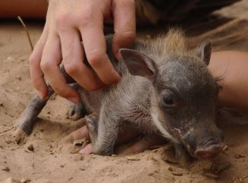
OTHER IMPORTANT JOBS THAT YOU MAY ASSIST WITH
C.A.R.E. doesn’t turn away any injured, orphaned or abused indigenous wildlife in need of help. Now-and-then a few domestic animals may need help too. As a volunteer at the centre you should be willing to adapt to the day to day surprises and also be happy to help in all areas;
- Meal worm care;
- Laundry
- The weekly shop
- Food collection
- Sorting donations, incoming food and off-loading it from the vehicles
- Helping various projects around the place; particularly making swings, ropes, ladders, hammocks
- Using your skills to help; are you a budding or experienced photographer, artist, accountant, marketing officer or something else which could be beneficial to C.A.R.E. in a particular way? Let us know and use your skills to MAKE A DIFFERENCE!
- Maintaining paths
- Clearing and maintaining areas of the centre
- Maintaining enclosures and/or facilities
- Gardening
- Cooking OR cleaning up after meals
- Walking the dogs
- Taking care of the cats
- Helping with other wildlife if we have any cases at the time; birds, squirrels, porcupines, warthogs, small buck, bush babies
- Cleaning out and feeding the Education Centre’s Guinea Pigs
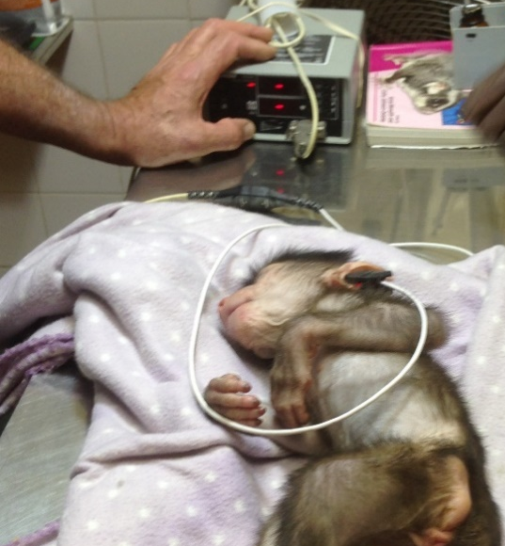
- Habitat assessments/vegetation surveys
- Cleaning and organising equipment
- Helping to fundraise

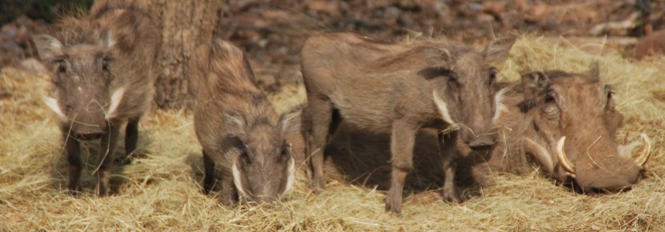

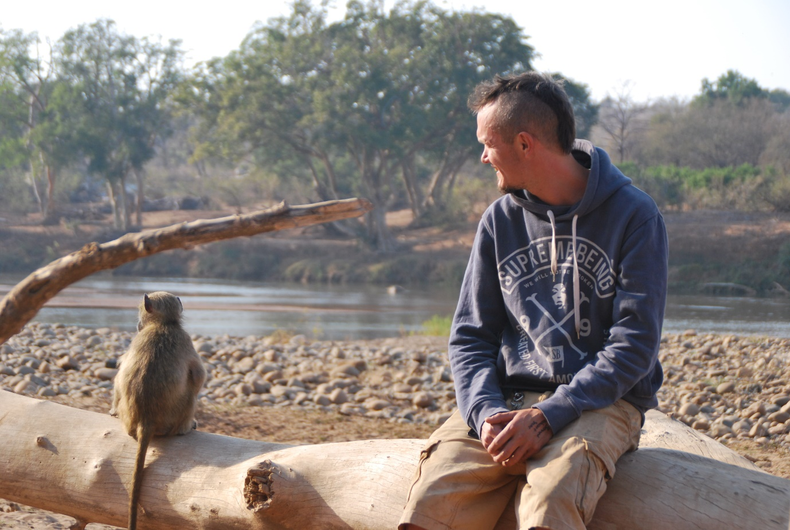
16

WHAT WILL I LEARN?

What you will take away from the experience very much depends on you! If you decide to spend your whole time socialising with the other volunteers, staring at your iPad and reading books then you may not learn much about Africa and the wildlife. We hope that you and the other volunteers will, however, be conscious of where you are and learn to live in the moment. We hope that when a wild baboon walks past you, that you will relish the opportunity to observe, learn and feel. It is very easy in today’s culture to forget how to live in the moment and we challenge you to do just that; realise YOU ARE IN AFRICA SURROUNDED BY WILD ANIMALS – WOW!!! If you are patient, humble, aware and appreciative you have the opportunity to learn so much!
We hope you will learn a lot about;
- Primate husbandry; contraception, rehabilitation, releases, monitoring, enrichment, cage cleaning, enclosure maintenance and the challenges we face to succeed; The baboons undergoing rehabilitation at the centre really do get the best start for a life back in the wild, learning about the wild animals around them and how to live as part of a family again. With magnificent birds of prey flying above, the orphan babies soon learn to duck out of sight or into the arms of the volunteer Baboon Care Givers. It’s always exciting for the staff and volunteers when the baboons make their unique warning calls, which echo throughout the centre, as then it is known that a crocodile, elephant or hippo has been spotted in the nearby river – a chance for everyone to grab their cameras to find out what they have spotted!
- A little about yourself; how did you cope living away from home, dealing with the heat, were you scared of the bugs?
- Baboon behaviour
- Wildlife vocalisations
- Wildlife habitats
- Working as part of a diverse team
- How to collect behavioural data
- How to be resourceful

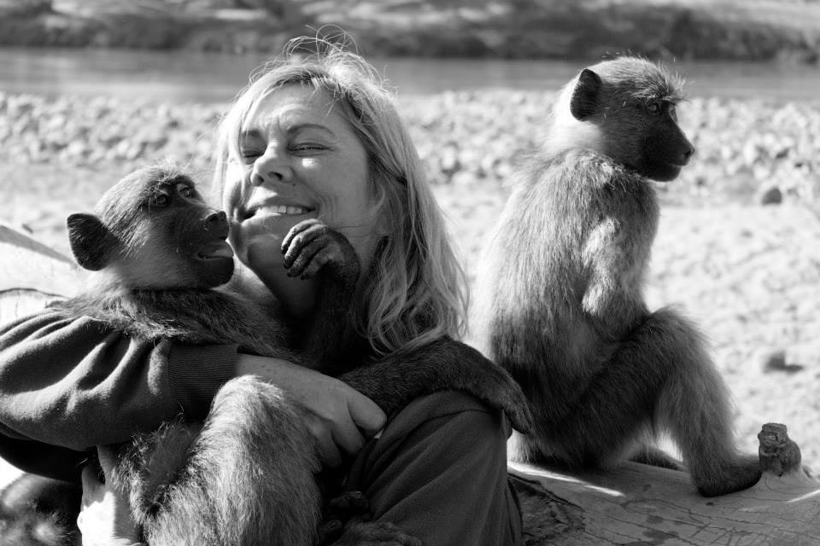

17

ADDITIONAL EXPERIENCES & EXCURSIONS

Dependable on the staff at the centre, what animals are in need of help and for what reasons and how busy the main team are you may also get an opportunity to;
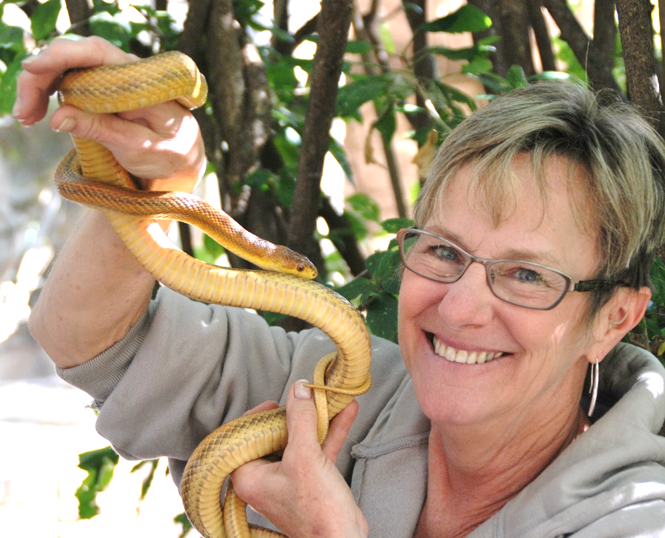
- Learn basic tracking skills
- Have a veterinary experience; faecal collection and analysis, observe procedures
- For an additional cost when you arrive you could learn how to dart (not using a live target/drugs)
- Take part in anti-poaching activities
- Visit release-sites
- Pre and post release research
- We urge all volunteers to visit other nearby rehabilitation projects and the Kruger Park (see EXCURSIONS below)
- Have a lesson in the native flora
- Take game drives around the Nature reserve
- Have sundowners at the picnic spot and spot the hippos

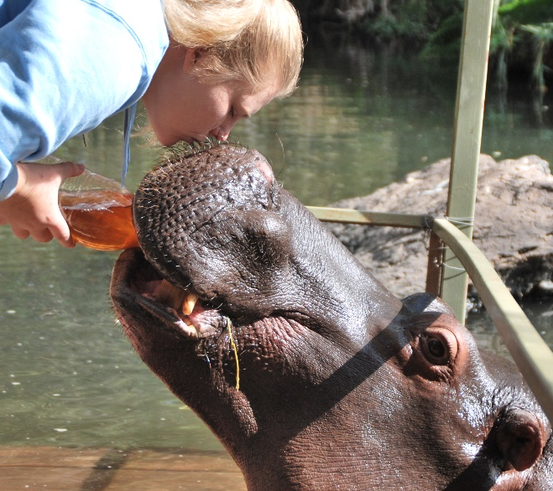
EXCURSIONS (see excursion costs)
As with the entirety of your stay, you embark on any of these experiences recommended below at your own risk. You can easily and at an affordable price hire a car nearby or see what trips the staff members are offering at the time but some of the nearby attractions include but are not limited to;
- The Kruger National Park (comes highly recommended)
- The Vervet Monkey Foundation (comes highly recommended)
- Hoedspruit Endangered Species Centre (comes recommended)
- Jessica the Hippo (many volunteers have reservations about the owners ethos but Jessica herself is incredible)
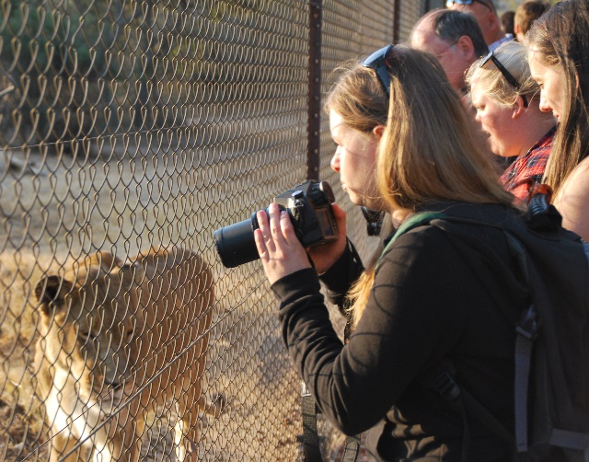
- Moholoholo Rehabilitation Centre where you get a tour of the animals housed there and Educational Talk about wildlife and rehabilitation in South Africa (many volunteers dislike the use of the cheetah for petting but overall an educational experience)
- Khamai Reptile Park where you can have either just a browse or a hands-on interactive tour where you may face your fears and hold a snake or tarantula (comes highly recommended)
- The Panorama Route (including God’s Window, the Three Rondevals, Sabie, Graskop, Bourkes Pot Holes, MacMac Falls, Lisbon Falls etc.) (comes highly recommended)
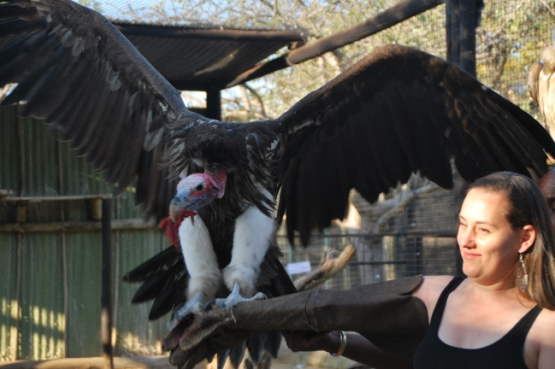
- Chimp Eden, a Jane Goodall Endorsed Sanctuary for chimpanzees where you get a guided tour (about 4 hours away) (comes highly recommended)
- Elephant Whispers/Sanctuary (we do not condone the use of elephants for tourism, 4 hours away)
- A day at the next door neighbours pool; Mfubu Lodge, owner Oli puts together delicious lunches for the volunteers for a small fee and the pool is just a 5 minute walk next door (comes highly recommended)
- Horse riding
- Zip lining (can be combined with Panorama Route)
- The Big Swing (can be combined with Panorama Route)
- Nearby lodges for a relaxing break
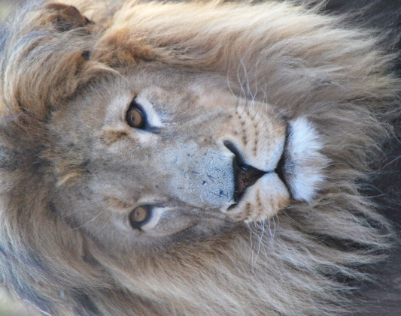
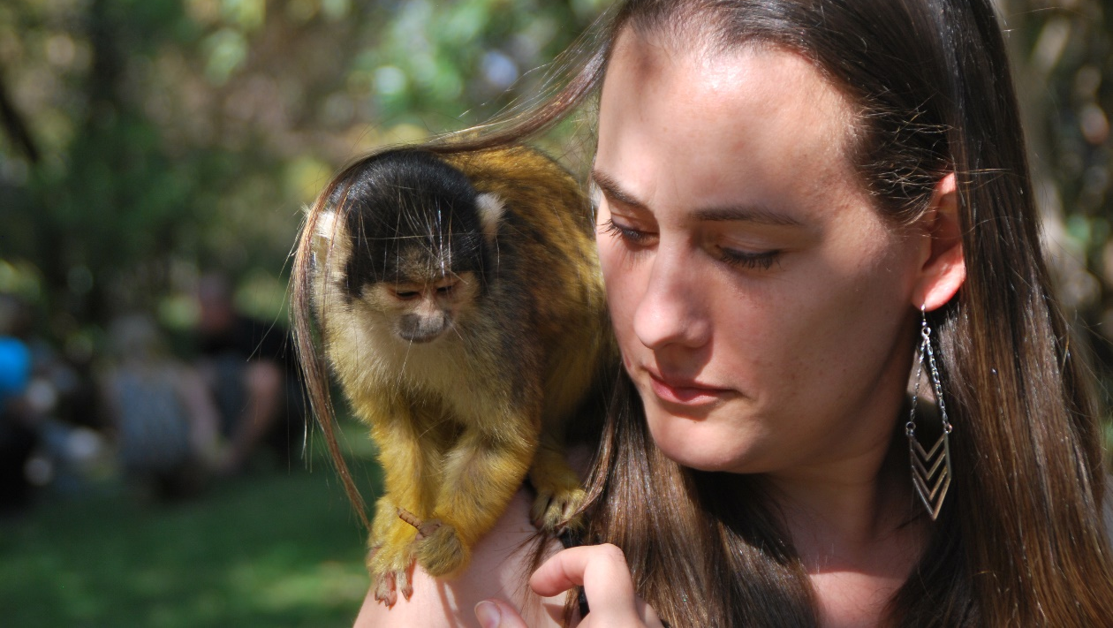

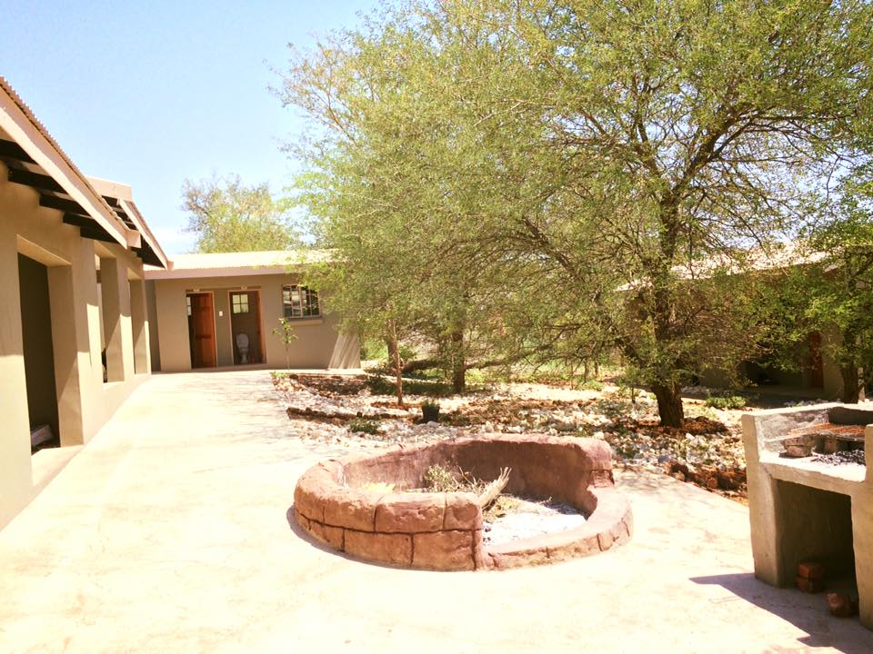

The beautiful new “Volunteer Village”

18

ACCOMODATION AND MEALS

As part of your volunteer donation we provide you with accommodation, hot and cold running water (showers, sinks and flushing toilets), a washing machine, electricity (220v) and meals.
As of 2016, we have finished our new “Volunteer Village”, thanks to the Boda Charitable Trust. The accommodation contains 6 rooms, each housing between 2 and 4 people each. There are new toilet and shower facilities, where volunteers get to wash while gazing up at the beautiful South African sky. There is a small volunteer kitchen, as well a communal games room, with ping-pong, darts, TV/DVDs. The bedrooms are situated around a beautiful communal garden space and braai area. The Volunteer Village is located within “The Rebuild” area, surrounded by a secure electric fence. Each room is equipped with 2 bunk beds, though depending on the number of volunteers; all the beds may not be full in your room. There are storage lockers in the rooms as well, so you have space to put away your clothes. Some of the rooms have desks as well.
For long-term vets/vet teams
We have one private room available in our clinic for long-term vets and vet couples. Please not that this room may not always be available during your stay and it is ONLY available to the vet volunteers. There is a separate shower and toilet adjacent to the clinic.
Long-term volunteers and staff members also sleep in the same buildings as the shorter/medium term volunteers; the Management team have separate living quarters.
- We ask volunteers to bring with them a mosquito net and towels. We appreciate all donations of these items too.
- WE DO NOT AS A STANDARD PROVIDE ROOM FANS. YOU CAN PURCHASE A FAN IN TOWN FROM BETWEEN R200-R500 (DEPENDABLE ON PREFERENCES).
- We provide pillows and a duvet (with sheet and covers).
- The mattresses are not very high standard as we cannot afford hotel standard equipment – if you suffer with a bad back and would prefer to purchase your own mattress from town and donate it to the centre upon your departure we would really appreciate all help and donations towards keeping the centre maintained.
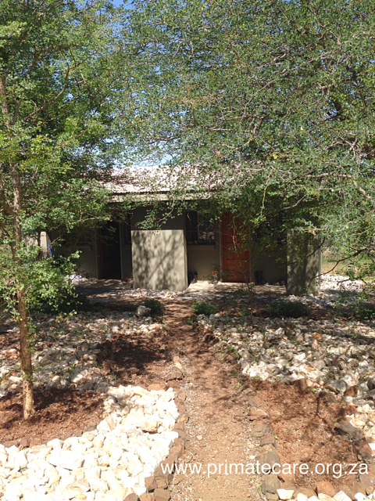
- We appreciate all donations of new sheets, duvets, pillows, covers, blankets etc. and you have the opportunity to purchase new from town if you prefer.
What will I eat?
As part of the volunteer fee, our volunteers are provided with food for breakfast, lunch, and dinner. We have just recently also finished our new Education Centre, where we have included a dining room. Breakfast and lunch are provided on the patio of our education center dining area. Dinner is served in the dining room of the education building and is prepared by staff and long-term volunteers. You may be asked to help prepare food or help clean up during your stay.
Our food is basic but filling! Any luxury items (chocolate, crisps, soda, etc.) can be purchased from our tuck shop, or bought in town on our weekly trips. We can cater to most dietary requirements including to vegetarians, vegans, gluten-free, etc. We cannot cater to those with extreme allergies- such as peanuts. Water from all taps in the rebuild is filtered and potable. Volunteers can also buy bottled water from the tuck shop if they prefer.
Two of the rooms in the Volunteer Village- lots of mature trees for lots of shade and beautiful rock gardens and paths.
Using a part of your Volunteer Donation C.A.R.E. buys food supplies each week for the meals. Again, we must stress that your donation was to help care for the animals you are coming to help and therefore the food we provide is basic essentials and not an all-you–can-eat restaurant or hotel standard. The funds from the volunteer programme fund the running of the centre, feeding +/- 440 baboons is expensive and caring for them is also costly. We try to budget the volunteer meals in order to also feed the animals at the centre and therefore, we urge volunteers who eat a lot or prefer certain tastes to purchase their own luxury food items at their own expense and have an opportunity to do so each week.
We provide all meals (excluding snacks) and your daily meals will generally consist of the following;
Breakfast; a selection of cereals/muesli, yoghurt, toast, milk, tea and coffee
Lunch; sandwiches, pasta, salads, savoury pies, etc. (if you as a person like to eat eggs, cheese etc. EVERY DAY then we ask you to buy a personal supply at your own expense)
Evening meal: Using basic ingredients, which are bought each week (tinned lentils, chickpeas, mixed beans, tomatoes, corn, fresh veggies such as broccoli, mushrooms, carrots, tomatoes, spinach, beetroot (beets), potatoes, grains such as rice and pastas), dinner is prepared for you. We primarily serve vegetarian foods. Typical dishes include; spaghetti bolognaise, baked potatoes, lasagne, veggie stir-fry, rice dishes, macaroni cheese and other pasta dishes, roasted veggies/chicken, “roast dinner”, pancakes, braii (South African variation of a BBQ), pizza and more.
Sometimes we offer the volunteers to take a trip into town for a small fee to cover fuel expenses (+/- R30 per volunteer; £1.50, $2) for an evening meal at a local restaurant or to buy take-away pizza/fish and chips. We try to arrange for a meal out each week but it varies depending on which staff are at the centre, how busy we are at the time and if all the vehicles are present.
There is a trip to town once a week for volunteers to purchase their own groceries if they desire additional items and there are fridges and cabinets to store personal food items in the volunteer kitchen area. One or two volunteers accompany a staff member each week and the rest of the volunteers give their shopping lists to the designated shopper. Some volunteers like to buy fizzy drinks, chips and chocolate, others prefer to buy healthier salads, fruit and specialist gluten-free or additional vegan substitutes. South African supermarkets cater for all cultures and tastes.
What are the bathroom facilities? There are toilet rooms available, as well as a separate sink room for hand washing/tooth brushing, etc. There are 2 open top showers with hot water. You’ll shower while gazing up at the beautiful African sky! There are additional toilets besides the clinic, new nursery building and Education Centre building but these are reserved for visitors or volunteers, which are assigned to shifts in those areas.
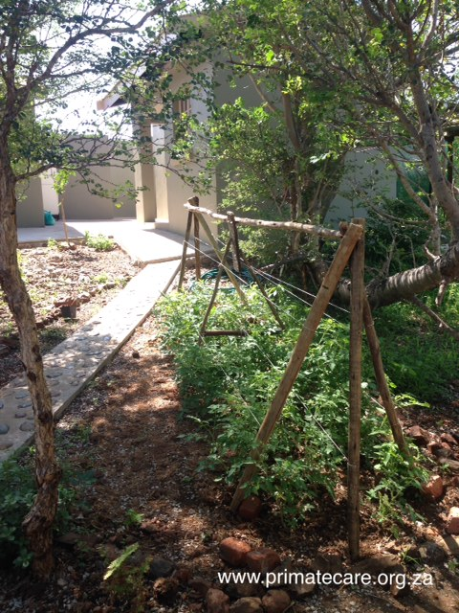
How do I keep in touch with home? C.A.R.E. is relatively isolated. There is no bus or passing traffic to get a ride into town. Please explain to your family that they are unlikely to hear from you on any regular basis. Once at the centre, you may only get to town once a week or two weeks. Upon arrival at Johannesburg we suggest you contact your family, and those concerned for your safety, to let them know you have arrived in South Africa.
The volunteer accommodation does not have a public phone or computer. To avoid viruses and unnecessary or expensive abuse, please respect that C.A.R.E.’s email and phone is off-limits to volunteers. Overseas calls will only be permitted in the case of emergency.
WiFi: There is basic Wi-Fi connection in the Volunteer Village (including in your room!) Internet is purchased via vouchers and MBs. 100MB for R10, 250MB for R20, and 500MB for R35. You can purchase as many vouchers as you like during your time at the Centre. Almost all volunteers use this Wi-Fi. It has limitations and you are not allowed to stream, download movies/music and should use it for basic use. You must remember we are in the South African bush so it is not very fast or reliable. Please note that there are times we are without power (due to a storm or South African “load shedding”) so we cannot guarantee the WIFI is always function great. We highly suggest you bring your own laptop, tablet, or Smartphone to use with the Wi-Fi.
One of the garden and vegetable patches in the Volunteer Village. We’re growing tomatoes in this one!
CELL PHONE: You can purchase a very cheap mobile phone or SIM card in town or at Johannesburg airport. MTN and Vodacom are the local carries and the centre gets decent cell reception (unlock your phone from home before you arrive to accept a local sim-card). Mobile phone reception at C.A.R.E. is sufficient to send and receive SMS/text messages, and is generally strong enough for phone calls. A voice call from a cell phone to the USA is around R12 ($1.60) per minute. A text message is approximately R2 ($0.30) per international text message of 160 characters. A cheap local cell phone is R150 ($15). Please note that it is not mandatory or imperative that you have a local cell phone; there is nowhere really to go where the staff or other volunteers will need to call you on a cell phone. However, please check with your family, as they may want you to have this option to keep in contact with you.
POST: South African post is notoriously unreliable. There is no delivery directly to C.A.R.E., but there is to a post box in Phalaborwa, which we check relatively frequently (weekly at best).
Please note that the post can take 3 or more weeks to arrive. Do not send valuable or perishable goods through the mail. Letters or packages can be posted to;

Your Name
c/o Centre for Animal Rehabilitation and Education
PO Box 1937
Phalaborwa 1390
South Africa

A TYPICAL VOLUNTEERS DAY
The following shifts are covered by volunteers on rotation;
Milk Bottles (making bottles, preparing food and giving the bottles); 6:00am, 9:30am, 11:30am, 1:30pm, 2:30pm, 3:30pm and any late nights as needed
Nursery Shifts: If we have orphan baby baboon in the first phase of rehabilitation they normally spend the whole day in the nursery with volunteers which they are comfortable with acting as their Uncles, Aunties and surrogate parents. We never leave an infant baboon alone or with volunteers they do not know as it is very damaging to their psychological wellbeing. Volunteers are taught how to interact and act as a safe harbour for the babies, ensuring they are eating and drinking and helping them to become confident. The time each volunteer spends in the nursery is dependable on how many volunteers we have at the centre and who the babies feel most comfortable with (specific volunteers may spend a lot more time than others), but if we have baby baboons in that phase of rehabilitation it is normally a minimum of three hours a day spent by each volunteer in the nursery.
“Supervised Bonding”: When we have orphaned babies in the “bonding phase” of rehabilitation we use volunteers to supervise and facilitate the bonding of orphaned babies to a new baboon surrogate mother (see How do I help “bond orphan babies to baboon surrogate mothers”?).
Phase II Enclosure Cleaning: put on your wellies (advised to bring a pair with you or you will have to use communal ones and may not be the right size/comfort for your taste), put on your over-alls or cleaning clothes, and your facemask and scrub! The baboons in the Phase II (hands-off) Phase of Rehabilitation require assistance from volunteers to keep their living space clean and hygienic. This is a VERY IMPORTANT job and every morning there are cleaning shifts with a tag-team of volunteers to help. The troop awaiting release are moved into one area of their enclosure and shut-off with a sliding door so that volunteers can safely enter to clean and maintain their enclosure.
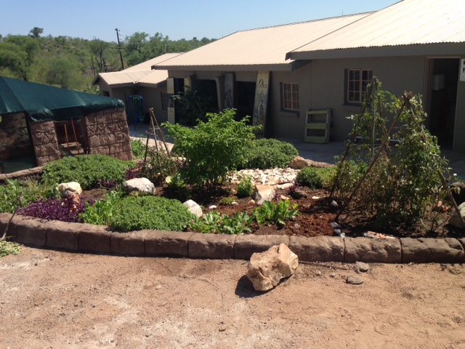
Have a green thumb? You may be asked to help in one of our vegetable gardens.
Sanctuary Baboon Enclosure Clean: put on your wellies and cleaning clothes and make it sparkle! Our sanctuary residents have smaller enclosures and volunteers normally do this alone (once trained) or in pairs.
Make Enrichment: learn how to make interesting items to enrich the animals’ lives! Some items are retrievable (foraging boxes etc.) and will need cleaning the next day.
Guinea-Pigs: the guinea-pigs need to be cleaned out, fed, given water, a health check and socialised in the morning and afternoon.
Other animals/birds: whatever animals we have at the centre at the time you are with us will need cleaning, feeding, socialising and supervising. We need your help to ensure they are well taken-care of. Most small mammals/birds have a shorter rehabilitation for release time and so may not spend long in our care/may have already been released or in Phase II Release before you arrive.
Projects: There are always various projects happening which may include enclosure renovations, enclosure cleans, making enrichments; hammocks, swings etc. Your help will be needed! Bring some gardening gloves as the manual work can be tough on hands.

A Typical Day May Include;
06:00—Morning bottle and food preparation and clean
06:30 – Giving morning bottles to babies that are weaned to adult baboon surrogates through the fence
07:00—Breakfast
07:30—Phase II Enclosure Clean & provisioning of new substrate (branches/grass/hay as available)
09:00 — Shower and change after the Phase II cleaning
09:30 – Food sorting (sorting bread/veggies and washing them)
10:00—Nursery baboon supervising/playing/giving bottles
11:00—Break
11:30—Clean and feed the guinea pigs and other animals/birds
12:00— Supervise bonding time of orphan baby and adult baboon surrogate
13:00—Lunch
14:00—Data collection
14:30—Bottle/food make and clean
15:00—Enrichment preparation and giving
15:30 – Browse collection (branch/grass or other foliage is collected)
16:00—Cleaning out of sanctuary baboon
17:00— Cleaning nursery
17:30—Clean the guinea-pigs and other animals/put them to bed
18:00—Take any orphan babies in Phase I rehabilitation to the river until dusk for last play-session for the day or stay with babies being weaned to adult baboon surrogates until dusk
18:30—Alien plant removal at river and wildlife spotting at the river
19:00—Dinner
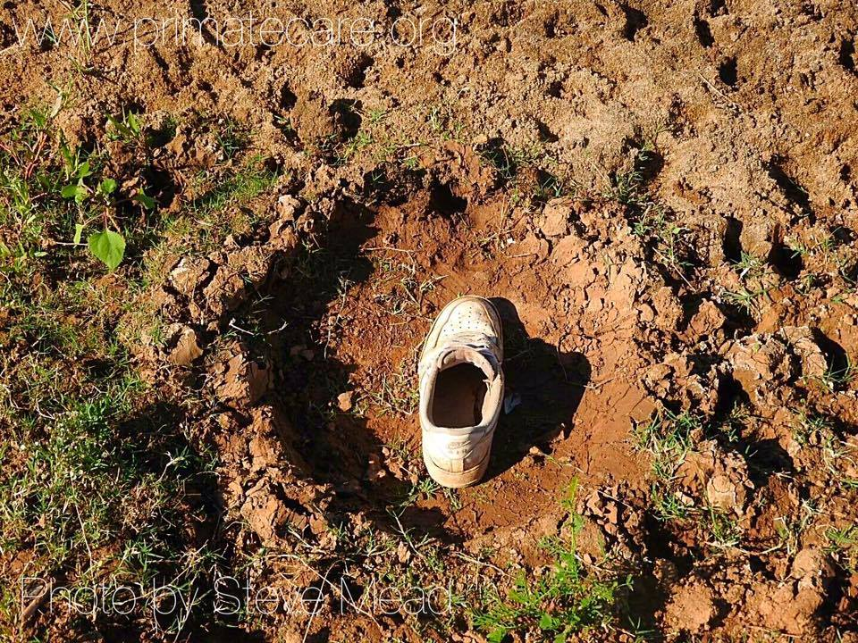
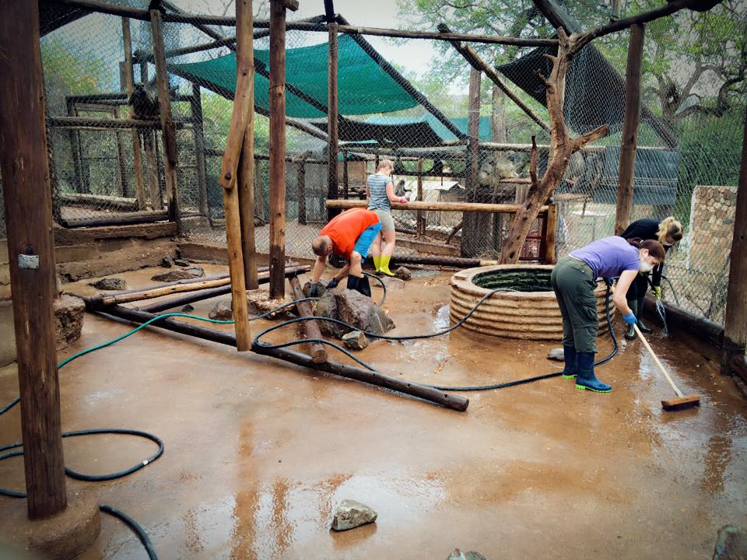
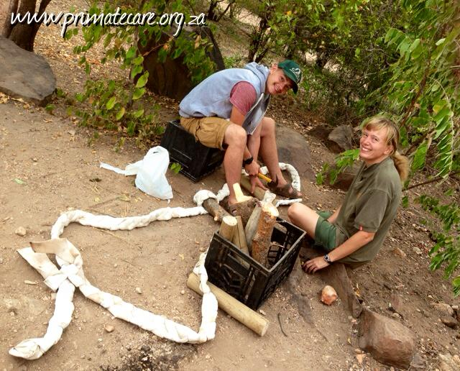
Spend time learning about tracks at the river. Who do you think made this one?
One of THE most important jobs of animal husbandry- cleaning to ensure every baboon has a healthy environment in which to thrive!
Help build swings and hammocks for the baboons using firehose and wood.

WHAT TO PACK

19

Weather:
Sept—Feb (spring/summer) is the rainy season when it will be extremely hot and humid, with temperatures usually in the 30-40+ Degrees Celsius (85-105 Degrees Fahrenheit).
May—August (winter) will be hot during the day (15-30 degrees C, 80 degrees F), with temperatures dropping at night (4 degrees C (minus some nights), 50 degrees F).
A duvet, pillow, and bed linens will be provided for you by C.A.R.E.
Mandatory Items:
- torch (flash light) – it is a very short walk to the bathrooms and night time is when scorpions and snakes are most active
- rubber gloves (or a pack of disposable) for cleaning/food prep
- face masks; it is mandatory to wear a facemask in the Phase II Rehabilitation areas – disposable cheap facemasks are suitable (paper/fabric with elastic to keep it secure) but feel free to bring fancier
- mosquito net
- pair of welly boots for cleaning shifts (or you will have to wear the communal pairs)
- closed-toe shoes for your working jobs (these can be old sneakers/hiking boots or comfy flats); you are not allowed to wear flip-flops during work time
- clothes for cleaning in (overalls? Specific pants/t-shirts) as these as a rule have to be different from those worn in the house/nursery
- clothes for the nursery (you aren’t allowed to wear the same clothes for cleaning as you do sitting in the nursery and you are not allowed to wear any of your work clothes in the rest areas); suggested quick dry pants/shorts and neutral coloured baggy light-weight t-shirts (tight tops get very hot and sticky and tank tops will be pulled down by the babies, t-shirts are preferred)
- clothes for resting in; lightweight pants/shorts, jeans, tank-tops, t-shirts and during the very hot summers- light weight dresses and skirts. For the winter bring a coat, gloves, a hat and fleeces.
- Towel (a pool towel and one for the bathroom – C.A.R.E. doesn’t provide towels. C.A.R.E. does have a trunk of old towels but these are also used for cleaning up things, if you could donate your towel after you leave it would be appreciated).
- Medications needed for the whole of your stay – there is a doctor in town but if you are on a specific medication please do not rely on the pharmacy here to stock your medicines
You will be able to purchase most goods in the area. However, bring essential personal items and personal medications.
Suggested Items:
- steel-toed work boots/hiking boots for project work; you may use hammers/heavy tools and for personal health and safety steel-toed boots are recommended (if you chose to wear regular closed-toe shoes for project work you do so at your own risk)
- flip-flops for rest time (flip-flops are only permitted to be worn during rest time as they are unsuitable for the terrain and for working with animals
- Burts Bees Herbal Insect Repellent; or a similar natural variety. Some natural repellents aren’t that good but many people recommend the Burts Bees Herbal Insect Repellent. The herbal varieties are kinder to the Earth and if the baby baboon licks it, or when it washes out of the shower into the environment you can be happier knowing the animals won’t be harmed. Deet is very toxic and it is damaging to amphibian life. You will need a repellent for the evenings especially in the summer.
- We suggest that you bring sets of ‘dirty’ clothes for the dirty, daytime work and another set of ‘clean’ clothes for after work, evening hours. Access to laundry facilities is usually once a week, so pack accordingly. (see mandatory clothing above)
- Washable walking boots/trainers, sandals/Crocs/flip-flops (see mandatory footwear above); Your shoes are going to get muddy and dirty and have the laces chewed. Bring more than one pair of shoes; you should have a few pairs of work/daytime shoes (trainers/crocs/boots) and one pair of after work/night-time shoes (trainers/flip-flops).
- Long-sleeve shirts and trousers; Insects can be a nuisance, especially after dark. This is also bordering a malaria zone so cool long-sleeve shirts and trousers are recommended to offer the best protection in the evenings.
- Sweatshirt/Jersey/Fleece; It gets cold in the winter mornings and nights, a few fleeces are recommended during this time.
- ‘Dirty’ Work Clothes Shorts or pants/trousers and t-shirts. Neutral colours are preferable. These clothes will get peed and pooped on and you may not want to wear them again later so bring clothes that you won’t mind getting dirty or ruined. There is a ‘communal bin’ of clothing that has been left behind by past volunteers, which you are welcome to use; most take advantage of this. Please leave behind unwanted clothing as when the communal clothing bins get full we give parcels of clothing to the local African workers. Removing any excess buttons is recommended before going in with the babies as otherwise they may remove them for you!
- ‘Clean’ t-shirts, shorts, and trousers to wear in the evenings after work, or on excursions out of C.A.R.E.
- Rainproof jacket and pants; the baboons need care in all weathers and even when it rains the babies want to play!
- Swimming costume for days off; however, you many NOT swim in the river due to crocodiles, but there is a lodge with a pool next door!
- Hat; a baseball hat is good to keep the sun off your face. A warm hat/’beanie’ is good for colder winter nights.
- Medical Kit
It is always useful to carry a small personal medical kit. This should include:
  - Personal medication to last the duration of your stay
  - Mild painkillers (e.g. Paracetamol or Advil) Band-Aids / Plasters
  - Neosporin
  - Anti-histamine cream/tablets
  - Antibacterial cream (e.g. Bactroban)
  - Rehydration solution and probiotics
  - Sun cream
  - Insect/mosquito repellent
  - Malaria tablets
- Toiletries
Most essential toiletries are available for purchase in Phalaborwa, but if you are particular to a certain brand it is best to bring it with you. It is also best to arrive with a few things in case we can’t get to town right away.
  - Shampoo
  - Conditioner
  - Body wash/soap
  - Washcloth
  - Razors
  - Toothbrush
  - Toothpaste
  - Hairbrush
  - Extra hair ties (A MUST!!As the babies love to steal them!)
  - Deodorant
  - Contact Lenses and solution
  - Tampons/Feminine Pads
Other Items (Non Essential)
- Camera, spare SD cards, batteries, chargers (remember all your power cords/charges/batteries as chances are you won’t find a spare in town – and Amazon doesn’t deliver to the bush!)
- Power adaptor (with 3 round prongs. This can also be purchased locally but not immediately usually)
- Penknife/Leatherman
- Binoculars
- Books—We also have a collection of books at the centre that you can read and swap
- Laptop—there is communal wifi internet connection
- External hard drive/Flash drive
- Duct Tape
- Water Bottle
- Backpack/daypack
PAST VOLUNTEER TIPS
- Bring movies – EVERYONE (including yourself) will be grateful.
- Read the list of things to bring!
- C.A.R.E. doesn’t supply fans as standard so when you visit the store buy one, they are about R250-R500 dependent on your preferences and will really help during the summer months. PS. GAME (a store in Phalaborwa) also sells portable air-con units, they’re really expensive (R3-5000) but may be worth buying for your room if you suffer from the heat (go halves with your roommates?). During winter C.A.R.E. provides you with an extra blanket, you may prefer to bring one or your sleeping bag.
- Make sure you take an adequate supply of contact lenses; your brand or script may not be available locally.
- Bring your own pair of welly boots and a set of clothes specifically for cleaning (light-weight overalls for example) and be kind enough to donate them at the end. You WILL wear wellies so you may as well bring a pair, which fit well and aren’t going to be shared with other people (imagine when you left your sports-kit at home when you were at school and the teachers made you wear someone else’s kit which didn’t fit and who knows who wore it…. better to be prepared).
- Make sure you have small change for the airport porters (R50 is ENOUGH, they will ask for more but more than R50 isn’t necessary)
- Don’t bring too much clothing—leave most of the fancy clothes at home and bring clothes that you will want to leave behind.
- Visit the dentist before leaving home—a toothache can really spoil your trip.
- Bring a credit/debit card linked to your accounts, and use it to draw cash from the ATMs. Do not bring travellers checks as the local bank doesn’t normally accept them. Also exchanging foreign currency takes HOURS (this is Africa), so avoid bringing foreign currency.
- Shops DO NOT accept foreign currency, bring only South African Rands
- Scan your passport, travel documents, tickets, etc before departure and be able to access the file in case of emergency.
- Label your luggage (it is easy to loose luggage so make sure the airline has no excuses!).
- Bring sunscreen and a hat.
- Bring all-natural insect repellent (the deet is sticky and tastes bad and the baboon babies might try to lick it, Burt’s Bees Herbal Insect Repellent works well and smells great and is kinder to the Earth)
- Be prepared to live without many modern conveniences.
- Avoid taking Imodium if you get a bought of travellers diarrhoea – whatever is inside your tummy needs to come out! Rather take a day off, eat some probiotics, get some rest and drink PLENTY of rehydration solutions. A trip to the doctor is also easy to arrange.
- Be prepared to get dirty!
- Take a day off! No one can work flat-out without burning out. It is important to get away from C.A.R.E. now and then so book your safari to Kruger and also once a week go to the lodge next door for a pool day – you won’t regret it and it will remind you how much you LOVE C.A.R.E. as guaranteed you will miss those sweet animals SO much!

SAFETY AT C.A.R.E.
When arriving all volunteers are given a tour, explained the safety and emergency procedures and provided with a Training Sheet which has further rules and safety advice.
The following advice and rule are for your own safety, those around you, and the animals.
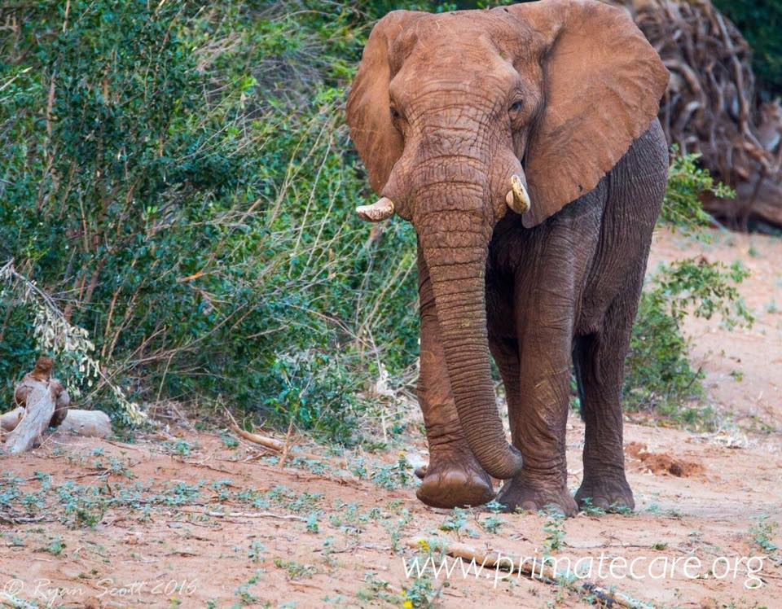
C.A.R.E. is situated in a nature reserve with wild animals. Be aware of your surroundings and keep your eyes open for any dangers. If you meet a wild animal back away slowly.
SAFETY AROUND THE CENTRE;
- Do not walk around at night without permission or unnecessarily. Never walk in the dark without a torch/flashlight. Do not go to the river at night or alone.
- Do not swim in the river—big crocodiles live there! Keep well back from the riverbank.
- Always close doors behind you, ensure padlocks/locks are fastened on enclosures.
- If you see a snake, back away slowly and call for help—it may be venomous and pose a threat to you and the animals. Never pick up a snake, even if it appears dead.
- Always walk around with shoes on. Volunteers must bring with them appropriate footwear for uneven, rocky terrain. Volunteers must wear closed-toed shoes unless resting indoors.
- Do not walk around the centre with headphones on listening to music. The wild sounds around you can alert you to any dangers, such as snakes, or fighting wild baboons.
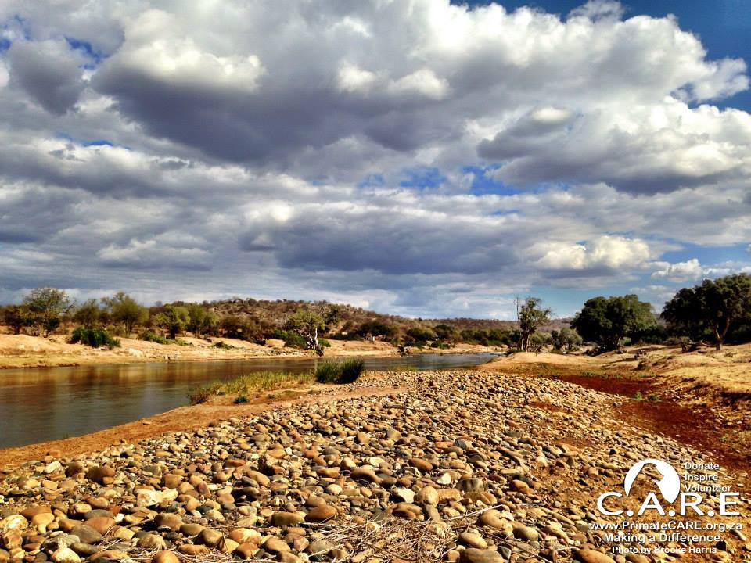
SAFETY AROUND THE ANIMALS;
- Be aware of your surroundings.
- Never enter an enclosure without permission.
- Be calm around the animals; screaming is reserved for emergencies; the management team do not appreciate false alarms!
- Never tease the wild baboons with food. If confronted, drop any food on the ground for them to pick up rather than handing it to them, and walk away.
- Never walk outside with food in hand/on view.
- Never try to take food or other items away from a wild baboon.
- No smoking around the animals and only in designated “smoking spots”.
- Don’t wear necklaces or earrings in the baboons’ enclosure, as they will pull at them.
- Close car windows if parked outside & lock doors.
- Quickly walk a safe distance away from any fighting baboons.
- Never walk or stand between a mother or father baboon/warthog and their baby.
- Never walk or stand between a male and a female in oestrus.
RULES FOR THE ACCOMODATION
- Tidy up after yourself, keep kitchen surfaces clean, put food away.
- Food left out = cockroaches = rats =snakes.
- We have a French drain/septic tank system. Do not throw things down the loo.
- No smoking indoors. Smoke only in the designated areas. Place butts in designated areas only.
- Drug usage of any kind is not tolerated at C.A.R.E. If any is found, it is grounds for immediate dismissal.
- Keep the dogs and cats out of your rooms (they are forbidden in the bedrooms as some volunteers may have allergies).
- Sleep under mosquito nets.
- Our water comes from a borehole. Drink only from taps in the Volunteer Village and rebuild areas, which is from the stored closed system. If you have a sensitive stomach, bottled water is available for purchase.
- Shake out shoes before stepping into them—scorpions and frogs love to sleep there.
- Leave hibernating tree frogs alone (small white frogs). Move spiders, lizards, geckos, and bugs outside if they are bothering you—don’t kill them as they serve an environmental purpose.
- Upon departure, please clean your room for the next volunteer and put your bed linens in the laundry.
- Please note that sound travels in the bush. Kindly turn off music and talk softly late at night.
- Do not have any sexual relations with the local African staff. This is cause for immediate dismissal from C.A.R.E.. If engaging into any sort of intimate relationship with another volunteer then ensure it does not affect your colleagues or role; it may cause you to be dismissed.
- Violence is not tolerated at the Centre. Any violence among volunteers can be cause for immediate dismissal from C.A.R.E.
IF IN DOUBT… ASK!

HOW YOU CAN HELP FURTHER
You can read more on our website; http://www.primatecare.org/#!how-to-help/cguq
We are urging all volunteers to set up a www.JustGiving.com/primatecare fundraising page – every little donation goes such a long way. One thing you can think about doing is sponsoring a baboon for their contraceptive implant, this can be fundraised through JustGiving.com or another way – if you do then you will be invited to watch the procedure in the Veterinary Clinic while you are here – along with getting a certificate of thanks.
Please spread the word on Facebook, hold a fundraiser or put up posters in your high traffic areas (downloadable on the website).
Or bring along one of the items mentioned below.
WHAT CAN YOU BRING FOR THE BABOONS?
Take a look at our wishlist available online;
http://www.primatecare.org/#!wishlist/c18l9
Items you can bring for the centre and the baboons (We WELCOME and NEED donations so PLEASE consider bringing something of the following for us)
- Size preemie up to size 2 baby nappies (for orphan baboons – human baby nappies are the best, we cut a hole for the diaper; Huggies and Pampers preferred unless preemie)
- Gardening gloves
- Marigold/rubber gloves or packs of disposable
- Packs of disposable face masks
- Mosquito tent and nets (please donate them to us)
- Multi-tools – SO useful!
- Deworming medication for the baboons (panacur, mebendazole based, ivermectin injectable or other)
- Veterinary equipment; ask us if there is something you have which may be useful. We need needles and catheters 18G – 23G are the most widely used sizes.
- Anti-biotics for the baboons (if you use Doxycycline as an antimalarial we would love any extras you have as it is often used in the clinic, any amoxyclav/amoxicillin based is also useful)
- NSAIDS for the baboons; metacam (or similar)
- Probiotics for the baboons; so valuable. We would REALLY appreciate Protexin (an animal probiotic) or human versions for adults and babies
- Good pliers
- Soft blankets – we prefer LARGER ones for the clinic and smaller ones for pouched babies
- Baby bottles and teats – especially teats!
- Bottle brushes
- Baby/pet pouches or slings
- Vitamins (Syrups or jelly tablets are the best – if its ok for dogs or children its perfect
for the baboons!)
- Veterinary books/supplies
- Kitchen/cooking utensils (our can openers ALWAYS seem to break!)
- Cups, plates, bowls (volunteers are not kind to our kitchen equipment)
- Cookbooks
- Razors (for the clinic) – always needed
- Toys for the baboons; durable rubber toys such as Kongs, balls etc. anything made for a dog will be ok for the baboons! The babies will be especially grateful.
- New movies, TV shows and music – the longer-term volunteers and staff will especially be grateful!

LARGER AND MORE EXPENSIVE PRIORITY ITEMS THAT WE NEED IF YOU WERE TO DO A FUNDRAISER
- Contraceptive Implants – if you raise the funds (R480 per implant) before you arrive we can fit the implant with you present if you were interested in the procedure
- Tools – multi-tools, power tools (screwdrivers) etc.

We are always in the process of releasing baboons and finalizing new release sites and setting these areas up for volunteers to visit and do research. For this we really need;
- GPS (hand held)
- Solar Charger suitable for GPS / Cell Phone / Satellite Phone
- Hand-held communication 2 way radios (basic Motorola/Samsung will be sufficient)
- Camera traps (with sturdy cases as baboons like to explore novel things – often with their mouths!)

We understand that collecting donations and/or fundraising can be time consuming and we are not expecting you to arrive with anything – just your helping hands and positive attitude is the most incredible gift that you can give to the baboons, thank you for confirming your stay with us.

Be prepared to leave a piece of your heart in Africa!

